Problems in Technology

MANUFACTURING MAYHEM
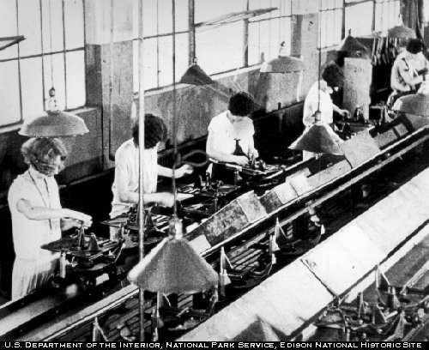

Your company had been selected to design and manufacture a product suitable for use by students in the 3rd-5th grades. The product must be designed in such a way that it can be mass produced. In addition to designing the product, your company will be required to develop the manufacturing processes required to produce the parts. And, create a flow process that will allow your product to be assembled using mass production techniques.

Company Name:

Team Members:

Production
Start Date: Hour:

Now that we know what to do, let’s get started!!!!

Phase 1:

Develop at least eight to ten ideas for products that meet the manufacturing requirements.

In order to have a successful production run you must take into account the technology resources required to manufacture your product.

Possible Product List:

1. 6:

2. 7:

3. 8:

4. 9:

5. 10:

Check here when completed 
Research and Development (R&D)

Phase 2:

Evaluate possible products to determine which product should be considered for further design and manufacturing.

You must include documentation has to how you arrived at your decision. For example, you could use market research to choose your product. Make sure you write a few paragraphs as to how you went about your research, did you interview students, develop surveys etc. You should include any research instrument in your documentation.

If you use something such as a design matrix be sure to include this information in your documentation.

There are a number of ways to choose a product; you may use more than one. Be sure to include all information and documentation in your final design brief.

Instructor signature here when completed

Time to Design

Phase 3:

Your company has selected a product, now its time to develop a specific design. You should create four or more designs (the brainstorming process).

Check here when completed 

Phase 4:

Using Google sketch-up or a C.A.D. program, draw your final plan. This is what you will be building from so be sure to include labels, dimensions, and any additional information required to produce the parts necessary for the manufacturing process.

Instructor signature here when completed

Time to Prototype!!!!!!!!!!!

Phase 5:

Its time to build the working prototype. Your team should build a working prototype of your product. Remember a prototype should be the same size as the finished product but it may not necessarily be as refined as the finished product.

Instructor signature here when completed

Phase 6:

Production Planning

In order to mass produce a product a company needs to have a production plan. (See pages 267-277 in the Technology: Engineering and Design textbook…the red one!!!).

Each component should have a unique name and part number. Once you have assigned these names and numbers a “Bill of Materials” should be completed for your product.

Bill of Materials
Part Number | Part Name | Quantity

Check here when completed 

Phase 7:

Flow Charts

In order to organize the production process a flow chart should be developed to show the manufacturing sequence. See pages 268-269 in the red textbook for an example.

Instructor signature here when completed

Phase 8:

Tooling-Up

In order to mass produce a product it is often necessary to create special tools to ensure each part is the same as the next. These special tools are called jigs or fixtures. To learn more about jigs and fixtures see pages 274-275 in the red textbook.

Identify and list any jigs and fixtures you will need to build for this project.

Jigs and Fixtures
Part Number | Part Name | Jig or Fixture required | Check off when Jig or Fixture is built

Instructor signature here when completed

Phase 9:

Pilot Run

It’s time to see if all of your hard work has paid off. Now we can answer the question: “WILL THE PRODUCTION PLAN WORK”??? In other words you are going to make a production run of one of each part and assemble the finished product. If everything works you are ready for production. If there are ANY issues you need to go back and fix them before you try another pilot run. See pages 276-277 in the red textbook for more details.

Instructor signature here when completed

Phase 10:

Mass Production

MAKE YOUR PARTS!!!!!!!!!!!!!!!!!!!!!! Much of the hard work is done, now it is time to start the mass production process. Determine the number of each part you will need to produce and begin making them. Keep all like parts together.

Before you get to far see phase 11, quality control…..

Phase 11:

Quality control, each part from the first to the last and everyone in between, needs to be the same. At calculated intervals you must take measurements and compare the mass produced parts to the original specifications.

Instructor signature here when completed

Phase 12:

Assembly

At this point you need to develop written instructions with a flow chart as to how to assemble all of the parts in order to create the finished product. Remember for this projects students in grades 3-5 will be assembling the product so the instructions must be written in words they can understand. Of course you can use as many pictures as needed.

Instructor signature here when completed

Guess what!!!!!!!!!!!!!!!! You did it, your team has just mass produced a product…..

