Problems in Technology

This IS A DRAG
OR…
IS IT A LIFT!!!!!

Aerodynamics
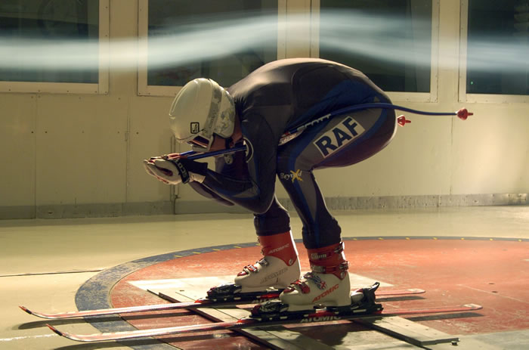

Our mission is to better understand the science and study of aerodynamics. Well, simply put aerodynamics is the way air moves around things. Aerodynamics is the reason planes fly. When is comes to being green (or just going faster) aerodynamics has a big influence on automobiles. In order to better understand aerodynamic forces, scientists often use a wind tunnel. Well guess what? We are going to become experts in aerodynamic by using our own wind tunnel!!!

Company Name:

Team Members:

Start Date: Hour:

Now that we know what our mission, let’s get started!!!!

Phase 1: Understanding the terms, there are a lot of terms related to the study of aerodynamics. Watch these cool movies and read through the following websites (feel free to explore on your own as well). This information will allow you to define these important terms.

Cool movies (click on the following links to watch some short movies):

Forces: http://www.grc.nasa.gov/WWW/K-12/airplane/forces.html

Weight: http://www.grc.nasa.gov/WWW/K-12/airplane/weight1.html

Lift: http://www.grc.nasa.gov/WWW/K-12/airplane/lift1.html

Drag: http://www.grc.nasa.gov/WWW/K-12/airplane/drag1.html

Thrust: http://www.grc.nasa.gov/WWW/K-12/airplane/thrust1.html

The racerchicks can give us a great overview!!!
http://www.racerchicks.com/qa/motor_aerodyn.html

NASA has some fun movies!!!

http://www.grc.nasa.gov/WWW/K-12/airplane/short.html

Aircraft Terminology:

http://www.owlnet.rice.edu/~mech594/handouts/aircraft_airfoils.pdf

Define the following terms:

Aerodynamic Center

Airfoil

Angle of Attack

Chord

Density

Dynamic Pressure

Drag

Lift

Surface Area

Thrust

Let’s build some paper airplanes!!!

Phase 2: Now that we know a little bit about aerodynamics, let’s see how it works in real life.

Your job is to do an internet search on building paper airplanes. Determine five designs, build and test them. Once you have built a plane put your name on it, then launch it over the railing.

MAKE SURE TO PICK UP ALL AIRPLANES!!!!!!!!!!!!

Rate the quality of flight for five different airplanes and put an “X” next to great, good, or poor that best describes the flight.

Estimate the hang time, count in Mississippi’s as to how long it takes the plane to reach the ground. Be sure to sketch the design in the “design” column.

Rate the distance of the flight and put an “X” next to really far, not to bad, or not good at all that best describes how far the plane traveled.

Design | Quality of Flight | Hang Time | Distance
 | Great  Good  Poor |  | Really Far  Not to Bad  Not good at all
 | Great  Good  Poor |  | Really Far  Not to Bad  Not good at all
 | Great  Good  Poor |  | Really Far  Not to Bad  Not good at all
 | Great  Good  Poor |  | Really Far  Not to Bad  Not good at all
 | Great  Good  Poor |  | Really Far  Not to Bad  Not good at all

Let’s build create an airfoil

Phase 3: Design build and test two air foils. Do an internet search to determine two designs for your airfoils. Draw the airfoils in the space below; make sure to include dimensions. You can use the provided airfoils for your test; sketch them below

Ask your instructor for material to build two airfoils.

Instructor Sign Off:

Using the following chart below to record your results and determine the performance of your airfoils.

Tunnel Data

The airspeed for the first part of the experiment is:

Airfoil A

The lift meter reading for airfoil A at 0 degrees is:

The lift meter reading for airfoil A at 2.5 degrees is:

The lift meter reading for airfoil A at 5 degrees is:

The lift meter reading for airfoil A at 7.5 degrees is:

The lift meter reading for airfoil A at 10 degrees is:

Divide each value by 1000 to get kilograms

The reading for airfoil A at 0 degrees in kilograms is:

The reading for airfoil A at 2.5 degrees in kilograms is:

The reading for airfoil A at 5 degrees in kilograms is:

The reading for airfoil A at 7.5 degrees in kilograms is:

The reading for airfoil A at 10 degrees in kilograms is:
Airfoil B

The lift meter reading for airfoil B at 0 degrees is:

The lift meter reading for airfoil B at 2.5 degrees is:

The lift meter reading for airfoil B at 5 degrees is:

The lift meter reading for airfoil B at 7.5 degrees is:

The lift meter reading for airfoil B at 10 degrees is:

Divide each value by 1000 to get kilograms

The reading for airfoil B at 0 degrees in kilograms is:

The reading for airfoil B at 2.5 degrees in kilograms is:

The reading for airfoil B at 5 degrees in kilograms is:

The reading for airfoil B at 7.5 degrees in kilograms is:

The reading for airfoil B at 10 degrees in kilograms is:

Dynamic Pressure

You are going to be calculating dynamic pressure for each of your airfoils and entering the number in a chart. Here’s how you do it!

Calculate the dynamic pressure using ρ= 1.225 kg/m³

The dynamic pressure is 1/2ρV² =1/2 ( ) ( )² =

Where: ρ = density of air in kilograms per cubic meter
V = velocity of air in meters per second.

Note: V must be in (meters/sec). To convert (miles/hr) to (meters/sec) multiply by 0.447

Surface Area

Calculate the surface area of each airfoil. Be sure to calculate your answer in square meters or convert your answer to square meters. (Show your work!)

The surface area of Airfoil A is (length x width x 2) sq. meters

The surface area of Airfoil B is (length x width x 2) sq. meters

Lift Coefficient

Calculate the lift coefficient (C_{L}= L/qS), where q= the dynamic pressure and S= the surface area) for each airfoil at the specified angle of attach. Each reading is multiplied by a drag factor to eliminate the drag force from the balance.

Airfoil A
L q S C_{L}

Angle of Attack | Lift reading (kg) | Divided by Dynamic Pressure | Divided By Surface Area | Equals Lift  Coefficient
0
2.5
5
7.5
10

Airfoil B

Angle of Attack | Lift reading (kg) | Divided by Dynamic Pressure | Divided By Surface Area | Equals Lift  Coefficient
0
2.5
5
7.5
10

In the space below graph your results. Use the X axis for angle of attack. Use the y axis for coefficient of lift. (Use a different color pen or pencil or different style of lines for each model tested in the wind tunnel). Don’t forget to put a key on your graph which tells what color or line style represents what model.

Let’s test some cars!

Phase 4: Use the chart below to compare the drag coefficient of each of the two cars provided by your instructor.

 | Drag Meter Reading | Divided by Dynamic Pressure | Divided by Surface Area | Equals Drag Coefficient
Car 1 |  |  | .00204m²
Car 2 |  |  | .00169m²

This one was fast wasn’t it? :)

Instructor Sign Off:

Phase 5: You are going to design a car that will be power by a CO₂ cartridge. These cars will be raced down a track and timed for performance. I will provide the body, wheels, axels, and of course the CO₂ cartridge. You will use the tools in the shop to create your car.

Start by creating four designs, some hints, what shape is your body going to be? Will it have wings or spoilers? What else can make it different and unique? As always feel free to use the Internet to develop some ideas, just don’t spend to much time there, these are your designs.

Design Note: Center of CO₂ hole MUST be between 1 ½” -2”, the minimum length must be .And, the minimum weight must be

You need to decide which one to build, let’s use our design matrix.

Select the Best Solution: Design Matrix
Complete the Design Matrix to determine the best solution / idea to solve the problem.

4 – meets perfectly  3 – meets well  2 – meets somewhat  1 – meets minimally  0 – does not meet | Solution 1 | Solution 2 | Solution 3 | Solution  4
Totals:

Using Sketch-up or a C.A.D. program, draw your final plan. This is what you will be building from so be sure to include labels, dimensions, and any additional information required to produce the parts necessary for the manufacturing process.

YOU MUST ATTACH THIS DRAWING TO YOUR PACKET

Instructor Sign Off:

Phase 6: Ask your instructor for a body and start building!

Phase 7: Place your car in the wind tunnel and record the lift and drag results.

 | Lift | Drag
Car

Using a scale, determine the weight of your car.

Using a stop watch record the time it takes your car to race to the end of the track.

Determine how fast you car is going (Note the track is 20 meters long).

Phase 8: Feedback, use complete sentences to describe how your car performed.

What did you like about your car?

What would you change if you had to do this over again?

