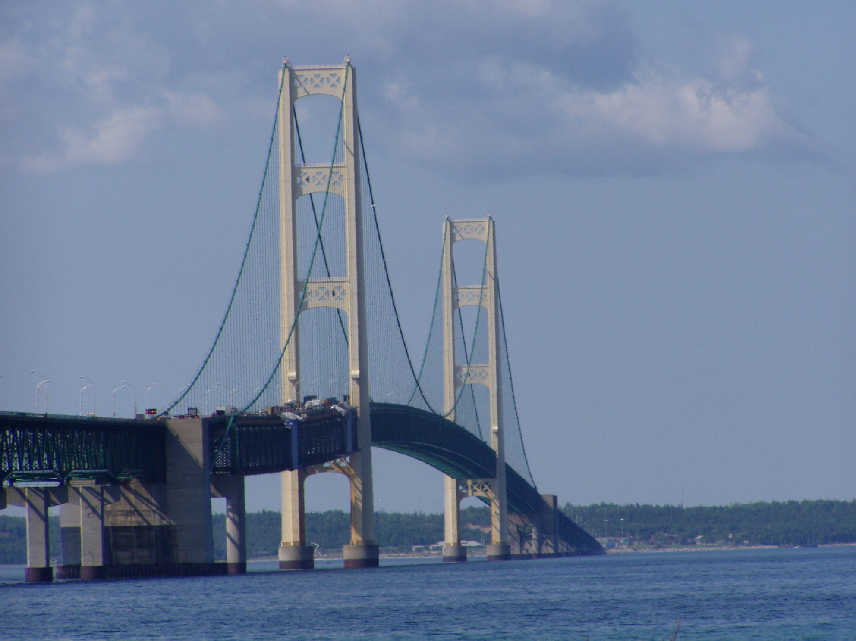

Name: ________________________ Name: ________________________

Group/Hour Code: ____________ Date: ____________

The challenge: Attention aspiring engineers and architects! The state of Michigan needs your help. The Mackinaw Bridge is beginning to deteriorate and a new bridge must be built. Our Governor wants the most qualified team of builders to oversee the design and construction of the new bridge. The Governor has issued a challenge to find the best bridge designers this country has to offer.

Identify the Problem

_______________________________________________________________________

_______________________________________________________________________

_______________________________________________________________________.

Rules:

1.

2.

3.

Set Goals (3pts)

1.

2.

3.

RESEARCH

Directions: Go to the following website:

http://www.pbs.org/wgbh/buildingbig/bridge/challenge/index.html

: Complete The Bridge Challenge
: Fill in the blank with the correct bridge for at each location

: 8 points

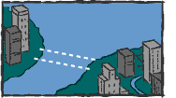
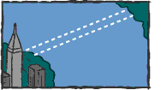

____1. ____2.

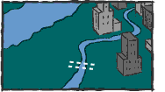
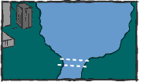

____3. ____4.

Research

Directions: Define the following items. Use 1-2 complete sentences to answer each item. Draw a sketch of each bridge in the box provided.

Types of bridges:

Suspension Bridge: (2pts)

________________________________________________________________________

_______________________________________________________________________.

Arch Bridge: (2pts)

________________________________________________________________________

_______________________________________________________________________.

Truss Bridge: (2pts)

________________________________________________________________________

_______________________________________________________________________.

Cable Stayed Bridge: (2pts)

________________________________________________________________________

_______________________________________________________________________.

Research

Directions: Define the following forces. Use 1-2 complete sentences to answer each force. Give an example of each force.

: Go to the following website

: http://www.pbs.org/wgbh/buildingbig/glossary.html#cantilever

Forces:

Compression: (3pts)
________________________________________________________________________

_______________________________________________________________________.

Example: _______________________________________________________________.

Tension: (3pts)
________________________________________________________________________

_______________________________________________________________________.

Example: _______________________________________________________________.

Torsion: (3pts)
________________________________________________________________________

_______________________________________________________________________.

Example: _______________________________________________________________.

Shear: (3pts)
________________________________________________________________________

_______________________________________________________________________.

Example: _______________________________________________________________.

Research

Directions: Go to the following website and watch the video

http://www.newtonsapple.tv/video.php?id=1286

: answer the following questions using complete sentences

What is the basic shape used in the bridge made out of three sheets of cardboard to support the toy truck? Why is this shape used? (3pts)

________________________________________________________________________

________________________________________________________________________

_______________________________________________________________________.

What type of bridge did the ancient Romans build? Why? (3pts)

________________________________________________________________________

________________________________________________________________________

_______________________________________________________________________.

How does a suspension bridge work? (3pts)

________________________________________________________________________

________________________________________________________________________

_______________________________________________________________________.

Why did the Tacoma Narrows Bridge fail? What could the builders have done to avoid the bridge from failing? (3pts)

________________________________________________________________________

________________________________________________________________________

_______________________________________________________________________.

Research

Directions: Research the following bridges.

Akashi Kaikyo Bridge (2pts) Tacoma Narrows Bridge (2pts)

Location: ___________________________ Location: _________________________

Type of Bridge: ______________________ Type of Bridge: ____________________

Year construction was completed: ________ Year construction was completed: ______

Brooklyn Bridge (2pts) Tower Bridge (2pts)

Location: ___________________________ Location: _________________________

Type of Bridge: ______________________ Type of Bridge: ____________________

Year construction was completed: ________ Year construction was completed: ______

Sydney Harbour Bridge (2pts) Golden Gate Bridge (2pts)

Location: ___________________________ Location: _________________________

Type of Bridge: ______________________ Type of Bridge: ____________________

Year construction was completed: ________ Year construction was completed: ______

Clark Bridge (2pts) Dames Point Bridge (2pts)

Location: ___________________________ Location: _________________________

Type of Bridge: ______________________ Type of Bridge: ____________________

Year construction was completed: ________ Year construction was completed: ______

Research
Directions: Answer the following questions using 3-4 complete sentences.

What would day to day life be like without bridges? (3pts)

________________________________________________________________________

________________________________________________________________________

________________________________________________________________________

________________________________________________________________________

________________________________________________________________________

_______________________________________________________________________.

What type of elements are bridges exposed to yearly? (3pts)

________________________________________________________________________

________________________________________________________________________

________________________________________________________________________

________________________________________________________________________

________________________________________________________________________

_______________________________________________________________________.

In your own opinion which type of bridge design is the best? Why? (3pts)

________________________________________________________________________

________________________________________________________________________

________________________________________________________________________

________________________________________________________________________

________________________________________________________________________

_______________________________________________________________________.
Create Ideas Draw three different bridges that you would like to build.

Thumbnail #1 (2pts)
Thumbnail #2 (2pts)
Thumbnail #3 (2pts)
Select the best idea

Design Matrix (5 pts)

4 meets perfectly  3 meets well  2 meets somewhat  1 meets minimally  0 does not meet at all | Sketch  1 | Sketch  2 | Sketch  3
Totals

Directions: Identify which bridge design you have decided to build. Explain why you choose this bridge in two or three sentences. ( 3 pts)

________________________________________________________________________
________________________________________________________________________
________________________________________________________________________
_______________________________________________________________________.

________Teacher signature

Final Drawings: Show your teacher your design matrix and ask for three sheets of graph paper for your final drawings. Your final drawing needs to be a full scale drawing. The final drawings must include a top and side view. Use a ruler and pencil. (18 pts)

________Teacher signature

Collect materials from your teacher to begin building your bridge.

Daily Work Log

Day | Date | What you want to accomplish | What you actually accomplished
1
2
3
4
5
6

