

Student Installation Guide for Multisim 12.0.1

Updated: 03/20/2016

Before you start

- As an enhancement to this year’s product offering, PLTW has added a student home-use option to allow students to access Multisim outside the classroom. There are TWO license numbers – please make sure the correct license is being used for its intended purpose.

LICENSE INFORMATION:

FOR STUDENTS’ HOME USE ONLY: License Number ___________________

- If you are running Windows 8. You will need to update the OS to Windows 8.1.

- At this time this product is not compatible with Windows 10.

Procedure- Installing Multisim

- Select the link below to download the installer: https://s3.amazonaws.com/support-downloads.pltw.org/Digital+Electronics+Suite/Step+1.zip

- Once downloaded, unzip the contents of the folder.

- Select the autorun application listed in the “Educational” folder under Step 1.

- Select Run, if prompted.

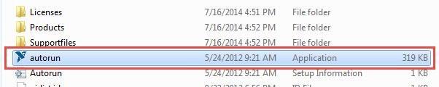

Page 2 of 7

5. Select Install NI Circuit Design Suite 12.0.
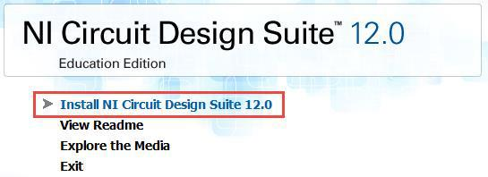

6. Select Yes, if prompted.
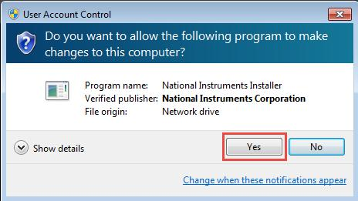

- If Microsoft .NET Framework 4.0 is not installed, you will need to do so by selecting OK and following the on screen instructions.

- Put Your Name, School Name, and the Serial Number provided by your instructor at the top of this document and select Next.

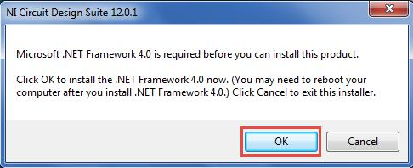
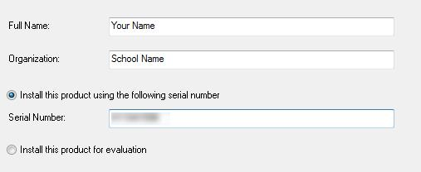

Page 3 of 7

- Keep the default directory and select Next.

- Select Do not install NI ELVISmx 4.x and Next.

- Remove the Check and Select Next.
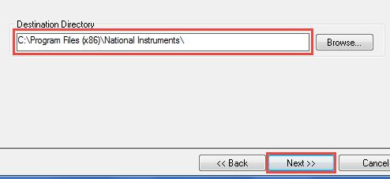
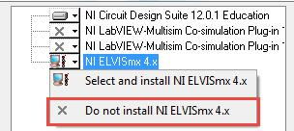
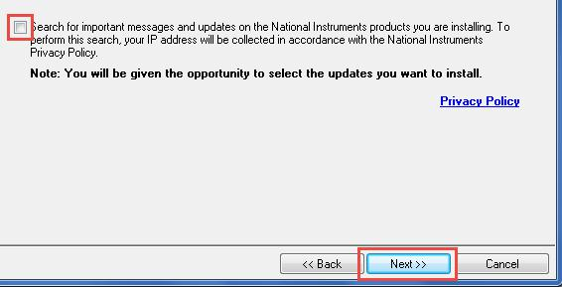

12. Accept the License Agreements and select Next.
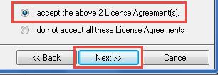

Page 4 of 7

13. Select Next and the installation will begin.
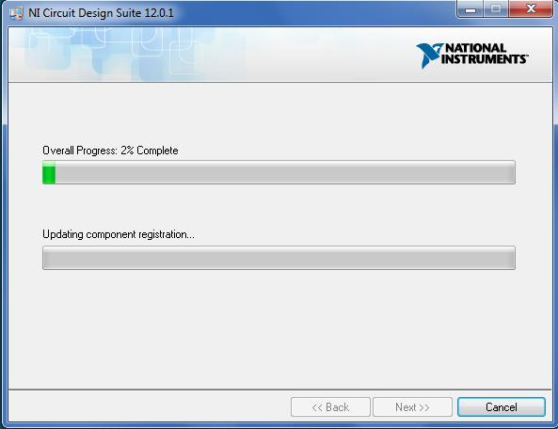

  - When the Installer finishes, select Next.

  - It will prompt for a system restart. Select Restart.

- Note: If you would like to manually reboot later after installing all of the Digital Electronics Suite, you can. You MUST Reboot before connecting any boards to the computer or using the software. **
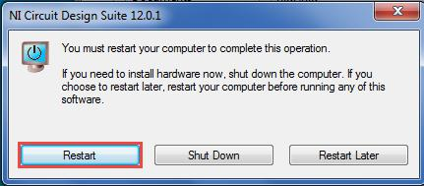
Procedure- Disabling the Automatic Update Feature

1. Go to All Programs > National Instruments > NI Update Service.
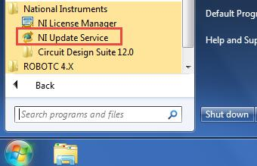

Page 5 of 7

2. Select File > Preferences.
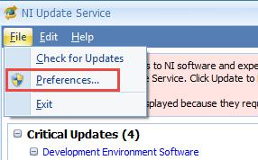

3. Select Yes, if prompted.
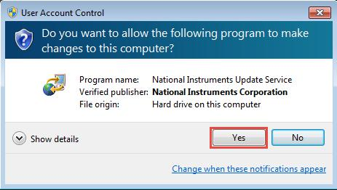

4. Remove the check for Enable periodic checking and select OK.
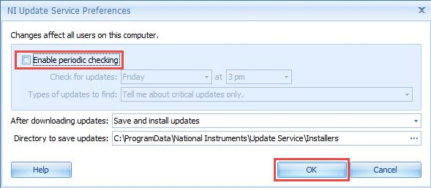

  - Close the NI Update Service.

Page 6 of 7

Procedure- Activating Multisim

1. Go to All Programs > National Instruments > NI License Manager.
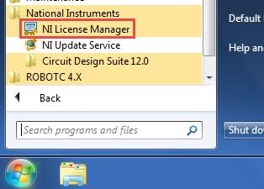

- Select the “+” next to Multisim to expand the selection.

- Right Click on Schematic capture and simulation and select Activate…

- Select Automatically activate through a secure Internet connection and Next.
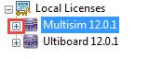
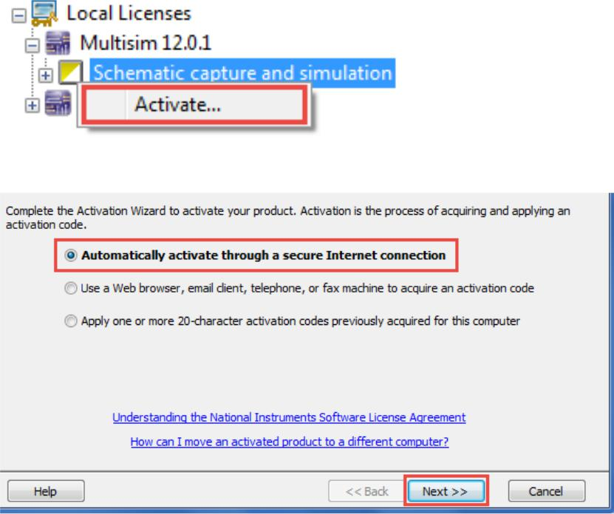

- Enter the Serial Number that is appropriate for your installation that is on page 1 of this document, if it is not shown and select Next.
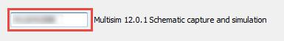

Page 7 of 7

- Fill out the on screen information with one of the two options and select next:

  - If you have a National Instruments account, Log in with your email or password.

  - Create a new User Profile and fill out the necessary information on the form.
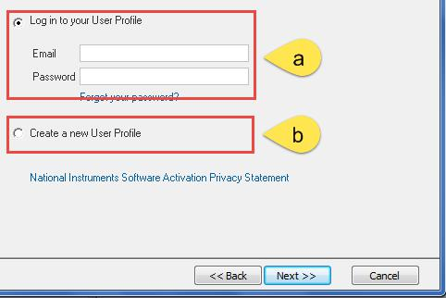

7. Uncheck the box and select Next.
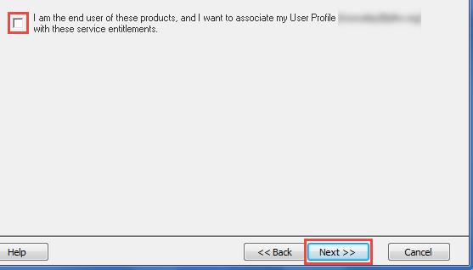

- Select Next and the Activation Process will be begin.

- Select Finish and your product is successfully activated and be reflected with a solid square in the license manager.
